Oklahoma State Department of Education FYT Report 2022
OEQA First Year Teacher Survey 2022
June 21st 2022, 11:23 am CDT
Q2 - Are you a first year teacher?
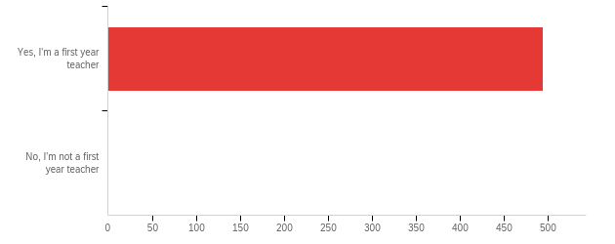

# | Field | Minimum | Maximum | Mean | Std Deviation | Variance | Count
1 | Are you a first year teacher? | 1.00 | 1.00 | 1.00 | 0.00 | 0.00 | 494

# | Answer | % | Count
1 | Yes, I'm a first year teacher | 100.00% | 494
2 | No, I'm not a first year teacher | 0.00% | 0
 | Total | 100% | 494

Q3 - Through which route did you receive your teaching license?
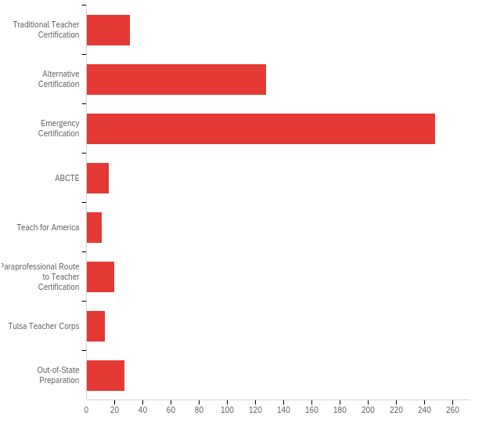

# | Field | Minimum | Maximum | Mean | Std Deviation | Variance | Count
1 | Through which route did you receive your teaching license? | 1.00 | 8.00 | 3.19 | 1.66 | 2.75 | 494

# | Answer | % | Count
1 | Traditional Teacher Certification | 6.28% | 31
2 | Alternative Certification | 25.91% | 128
3 | Emergency Certification | 50.20% | 248
4 | ABCTE | 3.24% | 16
5 | Teach for America | 2.23% | 11
6 | Paraprofessional Route to Teacher Certification | 4.05% | 20
7 | Tulsa Teacher Corps | 2.63% | 13
8 | Out-of-State Preparation | 5.47% | 27
 | Total | 100% | 494

Q4 - From which of the following institutions did you receive recommendation for teacher certification? If you hold an alternative or emergency certificate please select Oklahoma State Department of Education.
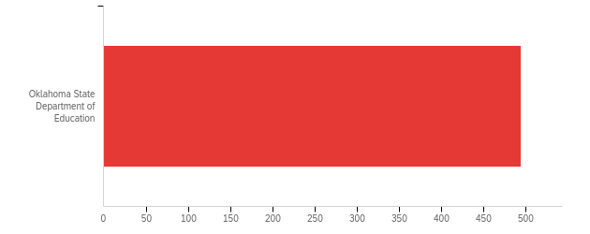

# | Field | Minimum | Maximum | Mean | Std Deviation | Variance | Count
1 | From which of the following institutions did you receive recommendation for teacher certification? If you hold an alternative or emergency certificate please select Oklahoma State Department of Education. | 12.00 | 12.00 | 12.00 | 0.00 | 0.00 | 494

# | Answer | % | Count
12 | Oklahoma State Department of Education | 100.00% | 494
 | Total | 100% | 494

Q6 - In what area did you receive your degree?
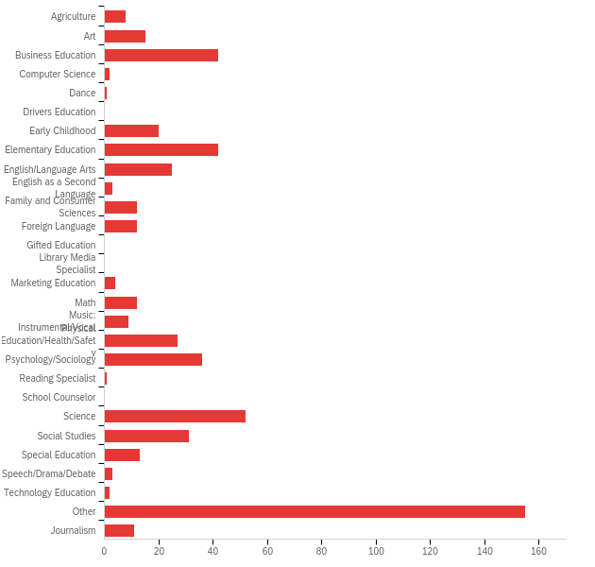

# | Answer | % | Count
1 | Agriculture | 1.49% | 8
2 | Art | 2.79% | 15
3 | Business Education | 7.81% | 42
4 | Computer Science | 0.37% | 2
5 | Dance | 0.19% | 1
6 | Drivers Education | 0.00% | 0
7 | Early Childhood | 3.72% | 20
8 | Elementary Education | 7.81% | 42
9 | English/Language Arts | 4.65% | 25
10 | English as a Second Language | 0.56% | 3
11 | Family and Consumer Sciences | 2.23% | 12
12 | Foreign Language | 2.23% | 12
13 | Gifted Education | 0.00% | 0
14 | Library Media Specialist | 0.00% | 0
15 | Marketing Education | 0.74% | 4
16 | Math | 2.23% | 12
17 | Music: Instrumental/Vocal | 1.67% | 9
18 | Physical Education/Health/Safety | 5.02% | 27
19 | Psychology/Sociology | 6.69% | 36
20 | Reading Specialist | 0.19% | 1
21 | School Counselor | 0.00% | 0
22 | Science | 9.67% | 52
23 | Social Studies | 5.76% | 31
24 | Special Education | 2.42% | 13
25 | Speech/Drama/Debate | 0.56% | 3
26 | Technology Education | 0.37% | 2
27 | Other | 28.81% | 155
28 | Journalism | 2.04% | 11
 | Total | 100% | 538

Q6_27_TEXT - Other
Other - Text
General Studies
Economics
Bachelor of Science in Business Admin
Liberal Studies
Organizational Leadership
Government and
Organizational Leadership
Bus. Admin. MBA
Musical Theatre
Engineering
Dentistry
Organizational Leadership
Communications
Child Development
Bachelor of Science, Biology
Social Work
Engineering
Criminal Justice / Occupational Safety and Health
B.A. Sociology & Human Services - M.S. Family & Child Studies
Hospitality and Tourism Management
Speech Pathology
Biology
Family and Child Studies
Interdisciplinary Studies
Interior Design
Business Management and Leadership
Social Work
Liberal & Applied Studies (Applied Behavioral Science)
Sports and Camp Admin
Corporate Communications
Chemical Engineering
Anthropology
Neuroscience
Environmental Engineering
Criminal Justice
Psychology
Applied Behavioral Sciences
Doctorate Medicine
General Studies
Education
Psychology/ Corrections
General Studies
Fashion Marketing/ Business Admin
Health and Human Development
Business Administration
speech and language
Health Care Administration
MA Leadership and Management
History
Family and Child Development
Human Relations
Strategic Communications
History
Mechanical Engineering
Behavioral Science and Ethics
Kinesiology
BA: religion
Exercise Science
Liberal and Applied Studies
Administrative Leadership
MBA
Criminal Justice and Spanish and Masters of Arts in Teaching Elementary
Biblical Literature
Youth Ministry
Political Science
Geography
Geography
Social Work
Sociology
Business Administration
General Studies
Ethnic Studies
BS Engineering Physics
General Studies
Mass Communication
Political Science
Finance
BS in Organizational Leadership and MA in Christian Studies and Leadership
Business Administration - Marketing
Organizational Leadership
Engineering
Human Services Counseling
Liberal Arts
BA: Gen Studies, MA: Music
Speech-Language Pathology
Master of Education Curriculum and Instruction
History
Business Administration
General Studies
Fire Protection and Safety Engineering Technology
Business
Cross-Cultural Studies
Anthropology
Business - Finance
Geography (G.I.S.)
Natural Resources Ecology Management
Business Administration
Integrative Studies
Masters in Healthcare Administration
General Studies
Business Administration
Sport Management - Marketing
political science
Educational Admin.
Accounting
Youth and Family Ministry
Education
Accounting
Near Eastern Languages and Civilizations
General Studies
Youth Ministry

Q7 - In what year did you receive your degree?
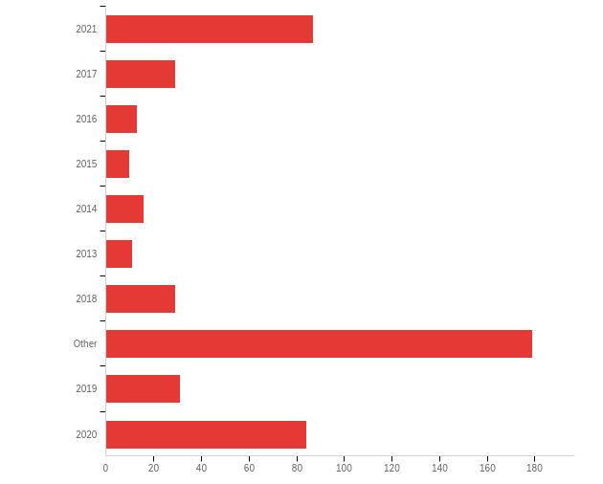

# | Field | Minimum | Maximum | Mean | Std Deviation | Variance | Count
1 | In what year did you receive your degree? - Selected Choice | 1.00 | 10.00 | 6.39 | 3.23 | 10.44 | 489

# | Answer | % | Count
1 | 2021 | 17.79% | 87
2 | 2017 | 5.93% | 29
3 | 2016 | 2.66% | 13
4 | 2015 | 2.04% | 10
5 | 2014 | 3.27% | 16
6 | 2013 | 2.25% | 11
7 | 2018 | 5.93% | 29
8 | Other | 36.61% | 179
9 | 2019 | 6.34% | 31
10 | 2020 | 17.18% | 84
 | Total | 100% | 489

Q7_8_TEXT - Other
Other - Text
2010
1995
2011
1993
1997
2010
2010
2012
2007
2004
1992, 1996
1991
2009
1983
1991
2007
2012
1993
2004
2000
2009
1995
2000
2008
2012
2007
2003
2000
2004
2002
1999
2003
2008
2005
2008
2022
2002
2011
2010
BS Zoology 1997, Doctorate Medicine 2001
1984
2008
2011
2011
2006
2005
2015
2001
1997
2001
2007
2012
2009
1998
2009
1998
2004
2005
2012
2003, 2007, 2016
1993
Still working on it
2005
2007
2010
2009
2011
2005
2004
2010
2011
2005
2014, Masters in 2017
2006
2005
2010
1994
2012
2010
2012
1998
2007
2010
2006
BA: 1989, MAA: 2016
2007
1994
2001
2008
1991
2006
2010
B.S. in 2007, M.S. in 2014, Ed.D. in 2021
2012
2012
1995
2005
2012
2010
2006
1999
2011
2007
2012
1994
2009
2012
1992

Q8 - The Learner and Learning Please rate the extent to which you agree with each statement below. My preparation program/route to certification prepared me to:
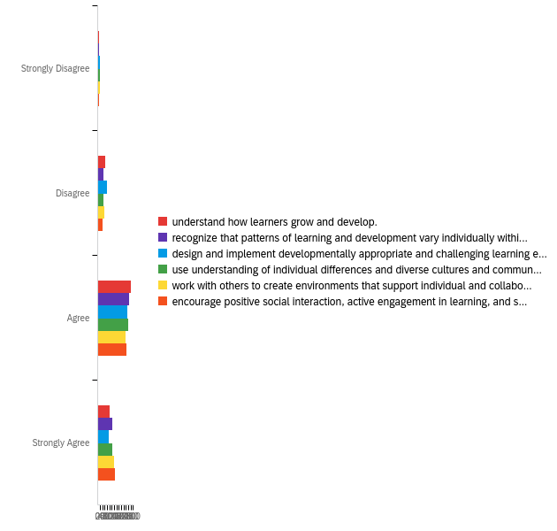

# | Field | Minimum | Maximum | Mean | Std Deviation | Variance | Count
1 | understand how learners grow and develop. | 1.00 | 4.00 | 3.02 | 0.69 | 0.47 | 454
2 | recognize that patterns of learning and development vary individually within and across the cognitive, linguistic, social, emotional, and physical areas. | 1.00 | 4.00 | 3.11 | 0.71 | 0.51 | 453
3 | design and implement developmentally appropriate and challenging learning experiences. | 1.00 | 4.00 | 2.93 | 0.76 | 0.58 | 453
4 | use understanding of individual differences and diverse cultures and communities to ensure inclusive learning environments that enable each learner to meet high standards. | 1.00 | 4.00 | 3.08 | 0.73 | 0.53 | 452
5 | work with others to create environments that support individual and collaborative learning. | 1.00 | 4.00 | 3.11 | 0.76 | 0.57 | 453
6 | encourage positive social interaction, active engagement in learning, and self-motivation. | 1.00 | 4.00 | 3.17 | 0.72 | 0.52 | 453

# | Question | Strongly Disagree |  | Disagree |  | Agree |  | Strongly Agree |  | Total
1 | understand how learners grow and develop. | 2.86% | 13 | 13.88% | 63 | 61.45% | 279 | 21.81% | 99 | 454
2 | recognize that patterns of learning and development vary individually within and across the cognitive, linguistic, social, emotional, and physical areas. | 3.31% | 15 | 10.60% | 48 | 58.28% | 264 | 27.81% | 126 | 453
3 | design and implement developmentally appropriate and challenging learning experiences. | 4.86% | 22 | 18.10% | 82 | 56.29% | 255 | 20.75% | 94 | 453
4 | use understanding of individual differences and diverse cultures and communities to ensure inclusive learning environments that enable each learner to meet high standards. | 3.98% | 18 | 11.28% | 51 | 57.96% | 262 | 26.77% | 121 | 452
5 | work with others to create environments that support individual and collaborative learning. | 3.75% | 17 | 12.36% | 56 | 52.98% | 240 | 30.91% | 140 | 453
6 | encourage positive social interaction, active engagement in learning, and self-motivation. | 3.09% | 14 | 9.93% | 45 | 54.30% | 246 | 32.67% | 148 | 453

Q9 - Content Please rate the extent to which you agree with each statement below. My preparation program/route to certification prepared me to:
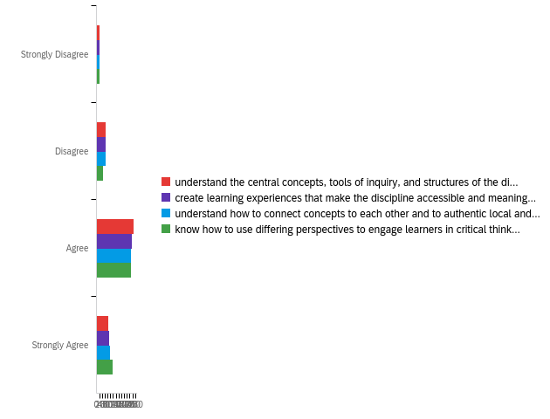

# | Field | Minimum | Maximum | Mean | Std Deviation | Variance | Count
1 | understand the central concepts, tools of inquiry, and structures of the discipline(s) I teach. | 1.00 | 4.00 | 2.96 | 0.72 | 0.52 | 437
2 | create learning experiences that make the discipline accessible and meaningful for learners to assure mastery of the content. | 1.00 | 4.00 | 2.96 | 0.74 | 0.55 | 437
3 | understand how to connect concepts to each other and to authentic local and global issues. | 1.00 | 4.00 | 2.98 | 0.75 | 0.57 | 436
4 | know how to use differing perspectives to engage learners in critical thinking, creativity, and collaborative problem solving. | 1.00 | 4.00 | 3.06 | 0.75 | 0.56 | 436

# | Question | Strongly Disagree |  | Disagree |  | Agree |  | Strongly Agree |  | Total
1 | understand the central concepts, tools of inquiry, and structures of the discipline(s) I teach. | 4.35% | 19 | 14.65% | 64 | 61.33% | 268 | 19.68% | 86 | 437
2 | create learning experiences that make the discipline accessible and meaningful for learners to assure mastery of the content. | 4.58% | 20 | 15.56% | 68 | 58.81% | 257 | 21.05% | 92 | 437
3 | understand how to connect concepts to each other and to authentic local and global issues. | 4.82% | 21 | 14.91% | 65 | 57.80% | 252 | 22.48% | 98 | 436
4 | know how to use differing perspectives to engage learners in critical thinking, creativity, and collaborative problem solving. | 4.59% | 20 | 11.47% | 50 | 57.57% | 251 | 26.38% | 115 | 436

Q10 - Instructional Practice Please rate the extent to which you agree with each statement below. My preparation program/route to certification prepared me to:
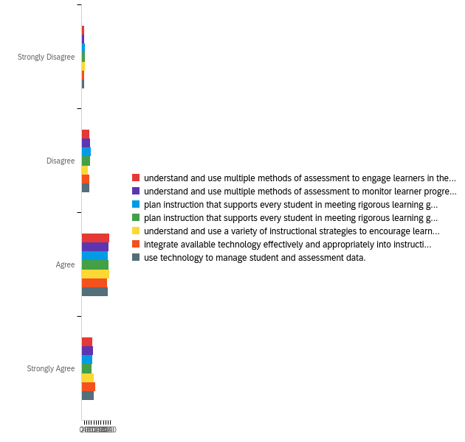

# | Field | Minimum | Maximum | Mean | Std Deviation | Variance | Count
1 | understand and use multiple methods of assessment to engage learners in their own growth and guide learners' decision making. | 1.00 | 4.00 | 2.97 | 0.77 | 0.59 | 407
2 | understand and use multiple methods of assessment to monitor learner progress and to guide my decision making. | 1.00 | 4.00 | 2.96 | 0.78 | 0.61 | 407
3 | plan instruction that supports every student in meeting rigorous learning goals by drawing upon knowledge of content areas, curriculum, cross-disciplinary skills, and pedagogy. | 1.00 | 4.00 | 2.90 | 0.81 | 0.66 | 407
4 | plan instruction that supports every student in meeting rigorous learning goals by drawing upon knowledge of learners and the community context. | 1.00 | 4.00 | 2.88 | 0.81 | 0.65 | 407
5 | understand and use a variety of instructional strategies to encourage learners to develop deep understanding of content areas and their connections, and to build skills to apply knowledge in meaningful ways. | 1.00 | 4.00 | 3.00 | 0.79 | 0.62 | 407
6 | integrate available technology effectively and appropriately into instruction. | 1.00 | 4.00 | 3.02 | 0.79 | 0.63 | 407
7 | use technology to manage student and assessment data. | 1.00 | 4.00 | 2.99 | 0.79 | 0.63 | 407

# | Question | Strongly Disagree |  | Disagree |  | Agree |  | Strongly Agree |  | Total
1 | understand and use multiple methods of assessment to engage learners in their own growth and guide learners' decision making. | 5.16% | 21 | 15.48% | 63 | 56.76% | 231 | 22.60% | 92 | 407
2 | understand and use multiple methods of assessment to monitor learner progress and to guide my decision making. | 5.16% | 21 | 16.95% | 69 | 54.55% | 222 | 23.34% | 95 | 407
3 | plan instruction that supports every student in meeting rigorous learning goals by drawing upon knowledge of content areas, curriculum, cross-disciplinary skills, and pedagogy. | 6.63% | 27 | 18.18% | 74 | 53.32% | 217 | 21.87% | 89 | 407
4 | plan instruction that supports every student in meeting rigorous learning goals by drawing upon knowledge of learners and the community context. | 7.13% | 29 | 17.69% | 72 | 54.79% | 223 | 20.39% | 83 | 407
5 | understand and use a variety of instructional strategies to encourage learners to develop deep understanding of content areas and their connections, and to build skills to apply knowledge in meaningful ways. | 6.14% | 25 | 12.78% | 52 | 56.51% | 230 | 24.57% | 100 | 407
6 | integrate available technology effectively and appropriately into instruction. | 5.16% | 21 | 15.23% | 62 | 52.33% | 213 | 27.27% | 111 | 407
7 | use technology to manage student and assessment data. | 5.41% | 22 | 15.48% | 63 | 53.56% | 218 | 25.55% | 104 | 407

Q11 - Professional Responsibility Please rate the extent to which you agree with each statement below. My preparation program/route to certification prepared me to:
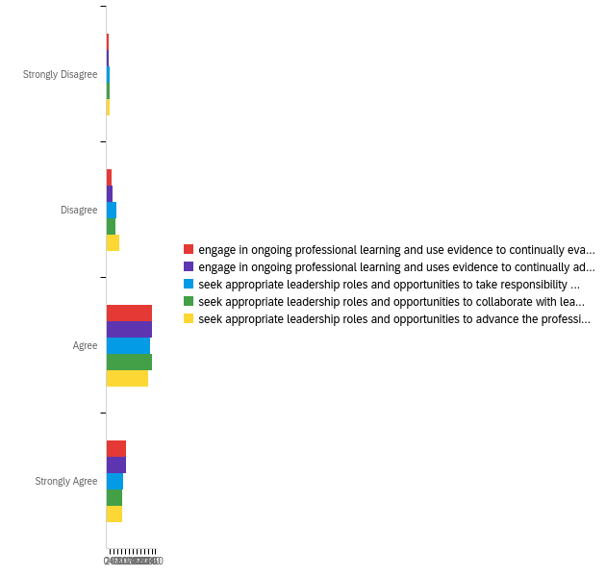

# | Field | Minimum | Maximum | Mean | Std Deviation | Variance | Count
1 | engage in ongoing professional learning and use evidence to continually evaluate my practice, particularly the effects of my choices and actions on others (learners, families, other professionals, and the community). | 1.00 | 4.00 | 3.11 | 0.69 | 0.48 | 394
2 | engage in ongoing professional learning and uses evidence to continually adapt practice to meet the needs of each learner. | 1.00 | 4.00 | 3.12 | 0.69 | 0.48 | 394
3 | seek appropriate leadership roles and opportunities to take responsibility for student learning. | 1.00 | 4.00 | 3.01 | 0.73 | 0.54 | 394
4 | seek appropriate leadership roles and opportunities to collaborate with learners, families, colleagues, other school professionals, and community members to ensure learner growth. | 1.00 | 4.00 | 3.01 | 0.72 | 0.52 | 394
5 | seek appropriate leadership roles and opportunities to advance the profession. | 1.00 | 4.00 | 2.95 | 0.75 | 0.57 | 394

# | Question | Strongly Disagree |  | Disagree |  | Agree |  | Strongly Agree |  | Total
1 | engage in ongoing professional learning and use evidence to continually evaluate my practice, particularly the effects of my choices and actions on others (learners, families, other professionals, and the community). | 3.81% | 15 | 7.61% | 30 | 61.93% | 244 | 26.65% | 105 | 394
2 | engage in ongoing professional learning and uses evidence to continually adapt practice to meet the needs of each learner. | 3.55% | 14 | 8.12% | 32 | 61.42% | 242 | 26.90% | 106 | 394
3 | seek appropriate leadership roles and opportunities to take responsibility for student learning. | 4.06% | 16 | 14.21% | 56 | 58.63% | 231 | 23.10% | 91 | 394
4 | seek appropriate leadership roles and opportunities to collaborate with learners, families, colleagues, other school professionals, and community members to ensure learner growth. | 4.31% | 17 | 12.69% | 50 | 61.17% | 241 | 21.83% | 86 | 394
5 | seek appropriate leadership roles and opportunities to advance the profession. | 4.57% | 18 | 17.51% | 69 | 56.60% | 223 | 21.32% | 84 | 394

Q12 - Overall, my preparation/route to certification effectively prepared me to have a positive impact on P12 student learning and development.
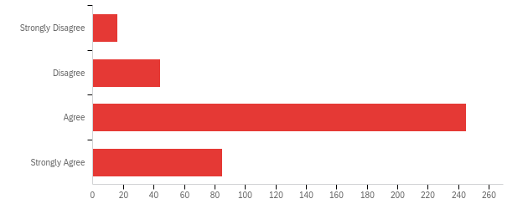

# | Field | Minimum | Maximum | Mean | Std Deviation | Variance | Count
1 | Overall, my preparation/route to certification effectively prepared me to have a positive impact on P12 student learning and development. | 1.00 | 4.00 | 3.02 | 0.70 | 0.49 | 390

# | Answer | % | Count
1 | Strongly Disagree | 4.10% | 16
2 | Disagree | 11.28% | 44
3 | Agree | 62.82% | 245
4 | Strongly Agree | 21.79% | 85
 | Total | 100% | 390

Q13 - What courses or experiences in your educator preparation/route to certification stand out as particularly important or meaningful?
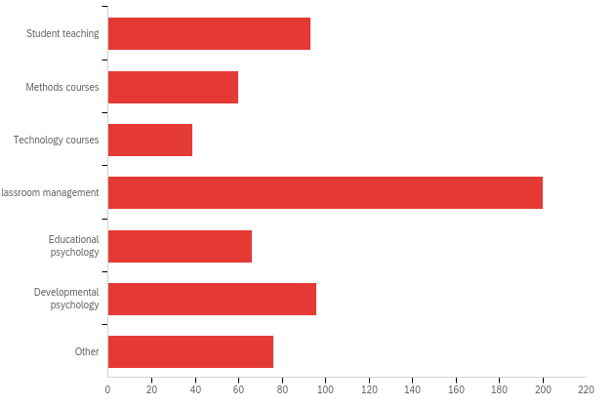

# | Answer | % | Count
10 | Student teaching | 14.76% | 93
11 | Methods courses | 9.52% | 60
12 | Technology courses | 6.19% | 39
13 | Classroom management | 31.75% | 200
14 | Educational psychology | 10.48% | 66
15 | Developmental psychology | 15.24% | 96
16 | Other | 12.06% | 76
 | Total | 100% | 630

Q13_16_TEXT - Other
Other - Text
Observations
Nothing stood out. There should be more on classroom management and implementation. Nothing you read can help with either. It’s experiences.
psychology
year as a para
I didn't have any of these courses. I am an emergency certificaton.
Management Experience
Child Development, Ethics, Social Psychology, and Educational Research
none
None
Mentor Teacher, LETRS Training, Instructional Coach, New Teacher Academy, PD Days
I have just began my process. I do not feel like I gained anything useful from the PPAT.
Working at a Teaching Assisstant
my instructional coach
1st Class Teachers meetings
Working with other first year teachers to try and figure out what would be covered in each of the above experiences
The Battery of Tests I had to pass
One on one talks
Mentors
Working in a school system prepared me the most
I wasn’t required to take any courses before my certification. However I think classroom management is the most important aspect of teaching.
I haven't had any yet.
Learning on the fly
Didn't take any courses to get certified
My SPED bootcamp was extremely helpful because of one great teacher who created comprehensive, thorough, and challenging courses.
None
working as a paraprofessional for a year
mentor teacher
Working as and with Teaching Assistants for Undergraduate courses
Professional Development
Being a paraprofessional in Special Education
mentors
N/A
I had no certification route courses
Experience in the classroom as a para.
On-site Mentorship
Mentori
NONE- and I had no student teaching
I don't take my educational courses until August 2022
literacy
Online alternative certification in Texas
Experience as a Paraprofessional
None

Q14 - As you near the end of your first year of teaching, in what area(s) could you have used more preparation? (Please check all that apply)
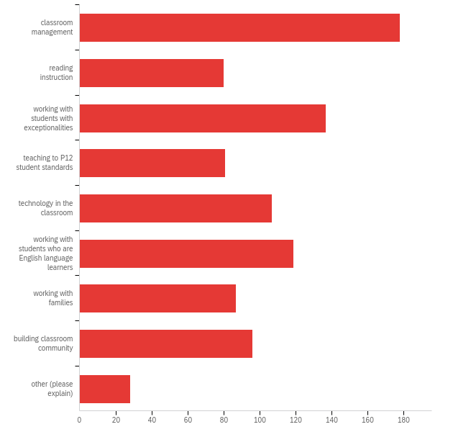

# | Answer | % | Count
1 | classroom management | 19.50% | 178
2 | reading instruction | 8.76% | 80
3 | working with students with exceptionalities | 15.01% | 137
4 | teaching to P12 student standards | 8.87% | 81
5 | technology in the classroom | 11.72% | 107
6 | working with students who are English language learners | 13.03% | 119
7 | working with families | 9.53% | 87
8 | building classroom community | 10.51% | 96
9 | other (please explain) | 3.07% | 28
 | Total | 100% | 913

Q14_9_TEXT - other (please explain)
other (please explain) - Text
Teaching student how to write!!!
Collaborating with teachers
Guidance on how to study for/pass OPTE.
A better way to educate students who are involved in activities that keep them out of the classroom such as sports
Student interaction, how to work with admins
Classroom management, classroom management, classroom management!!!
Effective lesson planning
Math Instruction
Working with difficult students.
Lesson Planning
Less Red Tape and very expensive hoops to jump through from state certification agencies (there is a teacher shortage for a reason)
Having a better understanding of what teachers did inside Oklahoma schools. (Such as when to give STAR testing, how we file students information) These things may also change from school to school.
Intervention methods for the children who got so far behind during COVID
I wish someone would teach new teachers how to deal with the emotions of the kids, especially in Middle School.
Having my own classroom would've been nice.
None. This is my last year teaching
Bureaucracy 101: Discarding all expectations of efficiency and common sense. Instead of striving for greatness or reward, this course would re-train you to only work to avoid reprimand. It would prepare you for constant expansion of demands with no further compensation. The instructor would give you expectations and goals and prepare you with tools to meet them. They would then demand that instead of using those tools to reach the goal, you'll spend all of your time documenting and testing and learning new soon-to-be-outdated-systems on trashy software that was contracted out for millions of dollars instead of just paying you more money to use your own tools and trust your own judgment. Etcetera. Etcetera. Etcetera.
Collecting Data
Taking state standards and developing curriculum in a set of lesson plans in an order that maximizes student learning.
Dealing with/ managing the extra paperwork and duties of a teacher.
None
All of these as related specifically to Algebra/Geometry/math core classes
Working for difficult administrators
ckla, eureka math, walk to read, MAP testing, wellness trackers, how to make lesson plans, what do you choose to teach when there is a 2 hour lesson and you only have 1 hour, how to teach with no books, or working printers onsite. how to grade papers, how to use powerschool, how to teach students to work independant
I would have benefitted from seeing the curriculum, getting access to digital platforms, and getting into my classroom weeks before school started instead of days before.
How to interact with Administration personal. I am in a Functional Skills room. I am the only one in the building and no one knows how classroom management looks like. I have interviewed other high functioning rooms to find out if I am doing the same as they are. Admin in my building is not understanding how I should manage my room.
grading and how to create rubrics

Q15 - Please note awards or honors received, degrees or certificates earned, and other recognitions from the current school year.

Please note awards or honors received, degrees or certificates earned, and other recognitions from the current school year.
I will graduate from SNU with a Masters of Administration of Special Education in December of 2022. I will also be initiated into the academic honors society, KDP at SNU.
Currently enrolled in LETRS training.
None. I completed them prior.
None
OSAT OGET Physical education NVQ personal training
N/A
NA
None
HERO of the month award.
MHSF Faculty Support Award, TNTP Tulsa's Bright Spot Teacher
None
2 grants in the amount of $1,500.00
I passed my OGET (December), OSAT (March), and PPAT(May).
Teacher of the year, Teacher of the month, PLTW automation and robotics certification, PLTW flight in space certification
Bachelors degree in Liberal Studies and Education
Emergency teaching certificate
I graduated with honors (Magna Cum Laude) and a bachelors of Science in Education. I was the Vice President and the President for one year of F.E.Y.C. (Future Educators of Young Children). I am currently emergency certified in my field, but I will receive the results from retaking the OSAT on May 13th. I am hopeful for a passing score so that I can receive a recommendation from Northeastern State University where I graduated from to apply for my Teachers Certification. So far this school year, I have received a certificate for OSTP Test Administrator training, Seizure Training, Dyslexia Awareness Training, and At-Risk for Elementary Schools Enhanced Training. I have had 3 in class observations by my principal and have received a score of 3 on every level for the end of the year/overall observation score. Throughout the year, my scores were mostly 3's, but I did receive a few Highly Effective and Superior scores as well. I have had a great school year and I absolutely love my school and my job! I am looking forward to many more years.
A student placed 1st at curriculum contest as my class representative.
I passed 2 of my required tests
About to start my 12 hours needed this summer.
Crisis Prevention Intervention Instructor
n/a
n/a
.
Vocal-Academic Excellence (OSSAA)
N/A
N/A
na
Literacy First Training
N/A
None so far
N/A
N/A
Oklahoma’s 20 Under 2 Novice Teaching Award 2022
Special Education Boot Camp for Severe/Profound Students.
My 8th grade broadcasting class earned 1st place in the short film contest sponsored by the Academy of Scholastic Broadcasting.
N/A
I was nominated for First Class teacher of the Year for Lawton Public Schools.
none
ABCTE Biology Certification Exam-DISTINGUISHED
I was nominated for the Rookie teacher of the Year.
No awards
LETRS Training - Mastery of Units 1-3
Oklahoma State Department of Education Teaching Certificate
none
OSDE TA Certification SDE Certification Mental Health First Aid USA Training
not the end of the year so IDK yet
Russian as foreign language ESL
Safari Club International - Oklahoma Division Teacher of the Year
I did not have any preparation/route for my emergency certification. I did however have an excellent mentor teacher that has been very thorough in helping me prepare for classroom teaching. I will be working toward my alternative certification beginning this summer.
n/a
Provisional Teaching Certificate
bachelor of science in elementary education.
Grant Winner
FCCLA Silver Chapter of Excellence Award FCCLA 50% Participation Award FCCLA 10 For the Win Recipient
Passed the OGET, and the OPTE.
None
Teacher of the Week
N/A
..
Currently take the LETRS course to better help my students with reading disabilities. I am a Sped teacher. Regularly recognized for student achievement in coursework and formative assessments.
Literacy First
certified in history and special education
N/A
I have completed 48 hours of the LETRS course online and book instruction. I have taken numerous hours of training outside the requirements from OK.
N/A
We became one of the top five schools in Aeronautics. We are beginning a Tango Flight program; we are only one of three schools in the state of Oklahoma. I have won a grant through AEP-PSO. I have also passed the OGET.
N/A
MacArthur High School Rookie of the Year
I will receive the American Board Biology teaching license at the end of the school year.
I am currently enrolled in a Graduate Study Program.
Art certification earned during the first year of teaching.
L
I received a few grants and the Teresa Kalman Brown Rookie Teacher Grant this year thus far.
n/a
Sheltered Instruction Certified
None
Now certified in business education.
n/a
Teaching Certification
N/A
N/A
Certificate of Giving from the United Way.
I’ve earned two grants and a third is up for evaluation.
Nomination for 20 under 2
NA
NA
First Class Teacher of the Year in my school.
Passed all three teaching tests - OPTE, OGET, and Elementary Education subtest 1 and 2
I've gotten countless certificates in a multitude of areas. OSTP proctor, administrator, DLM proctor, administrator, Reducing Challenging Behaviors in ASD, Introduction to Autism, CPR,Tons of Pepper modules, Principles for Developing Instructionally Appropriate IEPs. Etcetera. Etcetera. I completed the SPED Boot Camp in Challenging Behaviors. I have gotten no reward. What does that even mean? Am I supposed to get a plaque or something?
N/A
na
Professional Development Certification, Coaching Certifications, Emergency Certification
Earned Oklahoma Teaching Certificate this school year. Also credentialed to teach in CA.
Nominated for a new teacher award Certified in early childhood since 01/2020
ORCO Teacher Grant, awarded to 5 teachers only. County wide nominations were made by students and over 40 teachers were nominated. I received one of the grants for classroom supplies.
N/A
None at this time
Emergency certified in Elem. Education and making the required moves towards gaining certification as Special Education.
N/A
I was awarded high school teacher of the year and we are currently waiting to see who won district teacher of the year. I also started my master's degree this year.
None as of now
N/A
Mental Health First Aid USA Dyslexia Awareness 2021-2022 Trauma Summit: Connecting and collaborating for student success
BA SPED MM
n/a
Classroom Management Certificate
2nd year in the emerging leader program S.E.A.L
I went through Payne Education at my own expense to become a CALT. I am currently working on my Master's Degree in Reading.
n/a
None
Certificate of SPED
N/A
Earned a Reflex Math grant
na
Students attending State Science Olympiad and Regional Science Bee Finals BSA District Award of Merit BSA Lifeguard CPR and First Aid for the Professional Rescuer Completed OK Excel Communities of Practice Completed Picture-Perfect STEM Virtual Workshop with the Authors Hosted 3rd/9th Joint Science Fair
I was awarded the lifesaver award at my school.
Teacher of the week
Bachelors of Arts Public Administration Minor in Spanish
None
First OSSAA Wrestling Girls State Qualifier in school history
I have also received a certification in mild to moderate disabilities for Special Education.
Passed my OGET
Not sure what this means...this is the only certificate I completed during the year.
N/A
Passed the OGET Completed the OSDE Special Education Bootcamp Received the Emergency Teaching Certificate
N/A
I have all my classes to complete an Elementary Education Degree, I just did not get to do my student teaching due to covid making things to difficult so I decided to graduate with a Liberal and Applied Studies degree or it was going to take me a year longer to graduate. Plus there was going to be no way I would have been able to not work so I could student teach. I do not think that student teaching is set up very well at all. Very few people can afford to student teach. That is why I am emergency certification and trying to finish my testing. I feel like I was well prepared because of all the observation hours I did plus all of the education classes I took over the past few years.
none awarded
Tenacity Teacher of the Month at the Broken Arrow High School.
1. Master's in Educational Leadership in December 2020 (not current school year, but relevant to when my certificate was changed from alternative to standard). 2. Teacher of the month (December 2021).
I have passed my OGET.
COAC Coach of the Year, State Runner-up
I was awarded a grant from Donors Choose and from the State Department of Education for a classroom library project.
In progress
Graduated with honors
School Bus Driving Certification
None
None
I have been teaching for 6 years at a Charter School which I had no idea did not count but I have had my students excel and learn with successful years since I began teaching
Special Education Bootcamp Certificate
N/A
Learning Tree - New Teacher Training
In preparing for this year, I took 24 hours of education credit at University of Central Oklahoma. This year, I have completed year 1 of 2 for the LETRS training. I will also be pursuing the paraprofessional certification route for a standard teaching certificate.
N/A
MA in Christian Studies and Leadership
Working on my graduate courses right now. I have been nominated for an honor society for outstanding work at Northwestern Oklahoma State University. I have maintained a grade point average of over 3.3.
None
Emergency Certification
Completed/passed OPTE Attended OERB seminar
I passed my physical science OSAT and am awaiting the scores from my biology and earth science OSAT.
Alternative certification
Received 2 grants for my classroom.
BA Religion, minor English Cum Laude
I was able to finish 2 college courses before I was emergency certified. Classroom management and Pedagogy. I was doing the alternative certification route, before I was emergency certified. Now I am struggling to get the OGET passed. Nothing prepared me for that. I have been out of college since 2006. So i feel that the tests are causing a barrier on my completion. I love teaching in the classroom.
BA in General Studies, 1989. MA in Music in Jazz Studies, 2016.
NA
20 under 2 nomination
N/A
Rookie all-star teacher of the month
N/A
many pds
Golden Trojan award
n/a
After completing the OPTE I received a Standard certificate from the OSDE in November.
N/A
SAT proctor
Our 6th grade ELA scores has the largest growth from the district.
Rookie All-Star Teacher of the Month - December
NA
My students gave me a shout out for being a great teacher
N/A
n/a
I've taken the OGET and the English OSAT, as well as taken two college level courses on classroom management and designing instruction.
passed the ECE and ESL OSATs
Rookie of the Month January 2022
none
N/A
Working on OSDE Boot Camp for Special Education.
I participated in an adult art coalition in Carthage Missouri with professional artist. I received first honorable mention. My 4th grade students are partaking in the Philbrook Museum Big Show.
I am working on a Masters to meet the requirements of my provisional certification and I am studying to pass tests the four test that I still need to take.
None to my knowledge.
Pursuing Master's Degree and maintaining honer roll.
None
n/a
Mindset training completion
District coin
I really like the certificates that TPS offered to the teachers and all the support.
N/A

Q16 - Were you assigned a mentor from your school district this school year?
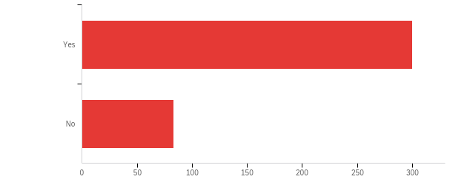

# | Field | Minimum | Maximum | Mean | Std Deviation | Variance | Count
1 | Were you assigned a mentor from your school district this school year? | 1.00 | 2.00 | 1.22 | 0.41 | 0.17 | 383

# | Answer | % | Count
1 | Yes | 78.33% | 300
2 | No | 21.67% | 83
 | Total | 100% | 383

Q17 - How much time did you spend with your mentor teacher?
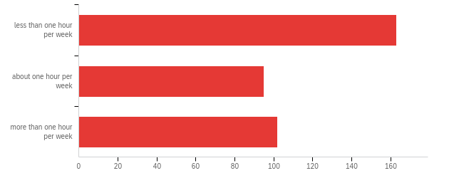

# | Field | Minimum | Maximum | Mean | Std Deviation | Variance | Count
1 | How much time did you spend with your mentor teacher? | 1.00 | 3.00 | 1.83 | 0.84 | 0.71 | 360

# | Answer | % | Count
1 | less than one hour per week | 45.28% | 163
2 | about one hour per week | 26.39% | 95
3 | more than one hour per week | 28.33% | 102
 | Total | 100% | 360

Q18 - Is your mentor in your same teaching area?
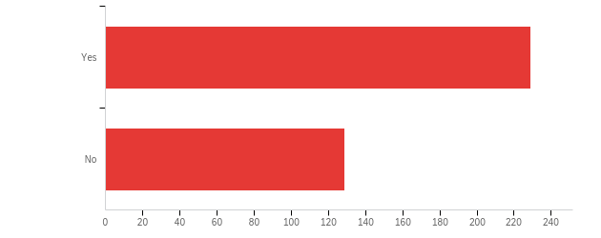

# | Field | Minimum | Maximum | Mean | Std Deviation | Variance | Count
1 | Is your mentor in your same teaching area? | 1.00 | 2.00 | 1.36 | 0.48 | 0.23 | 358

# | Answer | % | Count
1 | Yes | 63.97% | 229
2 | No | 36.03% | 129
 | Total | 100% | 358

Q19 - How satisfied are you with your mentoring experience?
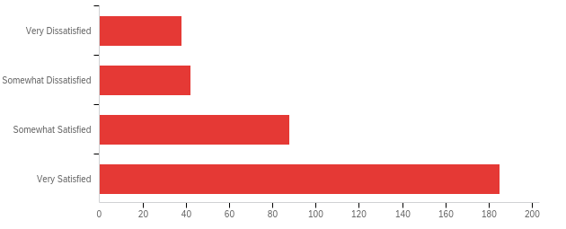

# | Field | Minimum | Maximum | Mean | Std Deviation | Variance | Count
1 | How satisfied are you with your mentoring experience? | 1.00 | 4.00 | 3.19 | 1.02 | 1.04 | 353

# | Answer | % | Count
1 | Very Dissatisfied | 10.76% | 38
2 | Somewhat Dissatisfied | 11.90% | 42
3 | Somewhat Satisfied | 24.93% | 88
4 | Very Satisfied | 52.41% | 185
 | Total | 100% | 353

Q20 - How might the mentoring experience be improved?
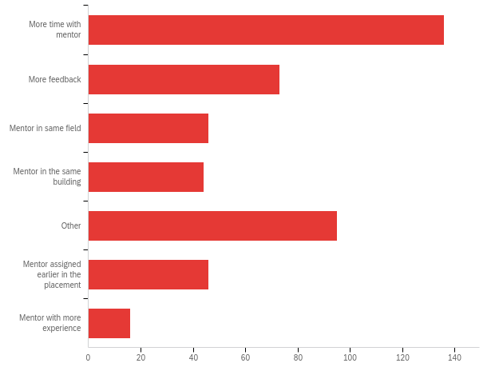

# | Answer | % | Count
1 | More time with mentor | 29.82% | 136
2 | More feedback | 16.01% | 73
3 | Mentor in same field | 10.09% | 46
4 | Mentor in the same building | 9.65% | 44
5 | Other | 20.83% | 95
6 | Mentor assigned earlier in the placement | 10.09% | 46
7 | Mentor with more experience | 3.51% | 16
 | Total | 100% | 456

Q20_5_TEXT - Other
Other - Text
More on hand or virtual observation.
I was not assigned a mentor
Comparability
A mentor more willing to check in
Mentor assigned at all
A new mentor assigned as soon as administration new she was resigning. I was the last to know and left wondering why I had not been seeing my mentor or hearing from her as much.
A mentor who acted like a mentor and not a Principal's assistant. Focus more on what her job actually entailed instead of caring about being everyone's boss.
my mentor left part way through the year. IF he would have been here the whole year that would have been better.
None
Less of a work load to be able to effectively do all that was required of me.
Because of circumstances beyond my site's control, my mentor was in a different grade level, which made grade specific questions and scheduling challenging
N/a
Mentor who was also a current teacher and could give insite on what worked and what didn't thier first year of teaching.
I have had an incredibly helpful and educational relationship with my mentor teacher. She has been accepting and supportive throughout the year as a first year teacher with an alternative emergency certification. She has helped me to feel very capable and empowered in this profession.
NA
nothing
Mentor was a fellow FCS teacher from a different school.
None
I never received a mentor.
Having a mentor...
There is nothing I would change about my mentoring experience. For others maybe making sure their mentor is actually willing to mentor them.
My mentor experience was excellent
She was great
Help with scheduling observations
No improvement needed!
She was amazing!
did not have a mentor
I have a team of mentors. Ann Lillich from the GearUp grant program, and all the teachers in my department who work collaboratively.
Actually having one would have been nice.
My mentor is an excellent mentor..
None
More positive attitude toward the relationship.
More guidance with IEPs and understandng before classes start
This particular mentoring experience has been great and I will be checking in with mentor after this 1st year is complete.
I am satisfied with my mentor
UTEACH PROGRAM
My mentor also has a student teachers so she is just very busy
Actually having a mentor
Less expectations!
I did not have a mentor teacher.
I did not have a mentor
I think just a better fit would help.
Mentor in the same grade.
my mentor was wonderful with answering all of my questions
its great
None
Time for my mentor teacher to observe me in the classroom
Get a mentor
My mentor was excellent. I feel really lucky to have had her as a guide.
Having two mentors: one that focuses on content and another that focuses on classroom management
Not reaching out to help, just filling a blank on a form.
She was wonderful. No complaints.
My mentor has been perfect.
Be more involved instead of mentor doing everything
No Mentor assigned
A mentor that doesn't keep saying I am doing great when I am begging for addiitional training and help
n/a
my mentor is awesome and has been very helpful and supportive
N/A
I didn't get a mentor.
Mentor that gives suggestions and feedbacks, but does not make things mandatory to implement.
A mentor outside of the classroom
N/A. Mentor provided enough support all around.
She is in lab I am in Functional Skills.
She was Great!
Formal Mentorship, this relationship wasn't a formal thing
It would be nice if we had the same planning period.
Very happy with mentor.

Q10 - In what area(s) were you initially certified? (Please check all that apply)
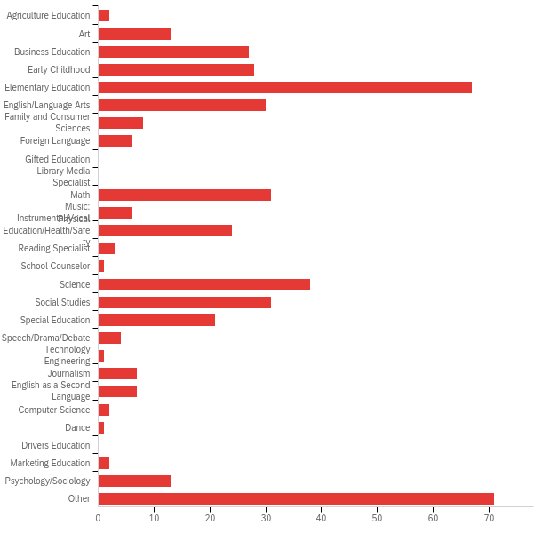

# | Answer | % | Count
1 | Agriculture Education | 0.45% | 2
2 | Art | 2.93% | 13
3 | Business Education | 6.08% | 27
4 | Early Childhood | 6.31% | 28
5 | Elementary Education | 15.09% | 67
6 | English/Language Arts | 6.76% | 30
7 | Family and Consumer Sciences | 1.80% | 8
8 | Foreign Language | 1.35% | 6
9 | Gifted Education | 0.00% | 0
10 | Library Media Specialist | 0.00% | 0
11 | Math | 6.98% | 31
12 | Music: Instrumental/Vocal | 1.35% | 6
13 | Physical Education/Health/Safety | 5.41% | 24
14 | Reading Specialist | 0.68% | 3
15 | School Counselor | 0.23% | 1
16 | Science | 8.56% | 38
17 | Social Studies | 6.98% | 31
18 | Special Education | 4.73% | 21
19 | Speech/Drama/Debate | 0.90% | 4
20 | Technology Engineering | 0.23% | 1
21 | Journalism | 1.58% | 7
22 | English as a Second Language | 1.58% | 7
23 | Computer Science | 0.45% | 2
24 | Dance | 0.23% | 1
25 | Drivers Education | 0.00% | 0
26 | Marketing Education | 0.45% | 2
27 | Psychology/Sociology | 2.93% | 13
35 | Other | 15.99% | 71
 | Total | 100% | 444

Q10_35_TEXT - Other
Other - Text
None
Healthcare administration
Communications
Early Childhood is the only area where I will be certified for now.
US History/Oklahoma History/Social Studies
N/A Emergency Cert
none
Sociology and Human Services - Family and Child Studies - Family Life Education
Hospitality and Tourism Management
Masters in Adult Education
i am not certified
none specific
SPED
Interior Design
Liberal & Applied Studies (Applied Behavioral Science)
n/a
NA
N/A
I was not certified previously
Chemical Engineering
MBA
None
None: emergency certificate to teach early elementary
Education
none
Organizational Leadership
None
Geography and World History
Social Work
Ethnic Studies
political science
wasn't previously cert
Public Health
Human Services Counseling
Speech-Language Pathology
None
None
none
I am not certified yet, I haven't passed any tests yet, so I am not sure how to answer.
Career Tech Business
N/A
I answered the first degree question wrong.

Q22 - What is your current primary teaching assignment? (Please check all that apply)
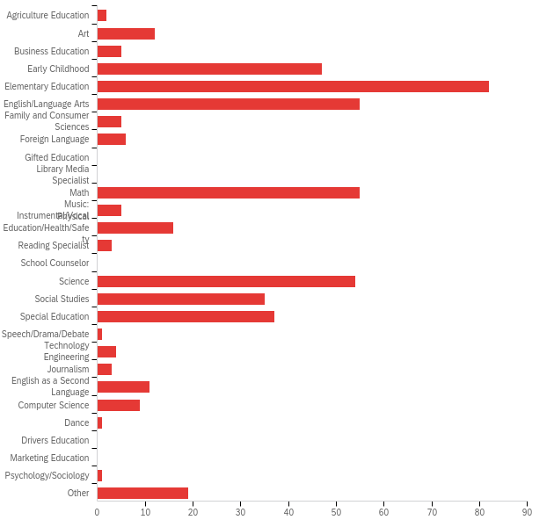

# | Answer | % | Count
1 | Agriculture Education | 0.43% | 2
2 | Art | 2.56% | 12
3 | Business Education | 1.07% | 5
4 | Early Childhood | 10.04% | 47
5 | Elementary Education | 17.52% | 82
6 | English/Language Arts | 11.75% | 55
7 | Family and Consumer Sciences | 1.07% | 5
8 | Foreign Language | 1.28% | 6
9 | Gifted Education | 0.00% | 0
10 | Library Media Specialist | 0.00% | 0
11 | Math | 11.75% | 55
12 | Music: Instrumental/Vocal | 1.07% | 5
13 | Physical Education/Health/Safety | 3.42% | 16
14 | Reading Specialist | 0.64% | 3
15 | School Counselor | 0.00% | 0
16 | Science | 11.54% | 54
17 | Social Studies | 7.48% | 35
18 | Special Education | 7.91% | 37
19 | Speech/Drama/Debate | 0.21% | 1
20 | Technology Engineering | 0.85% | 4
21 | Journalism | 0.64% | 3
22 | English as a Second Language | 2.35% | 11
23 | Computer Science | 1.92% | 9
24 | Dance | 0.21% | 1
25 | Drivers Education | 0.00% | 0
26 | Marketing Education | 0.00% | 0
27 | Psychology/Sociology | 0.21% | 1
35 | Other | 4.06% | 19
 | Total | 100% | 468

Q22_35_TEXT - Other
Other - Text
I just recently became an assistant cheerleading coach for our high school.
N/A Emergency Cert
Interior Design
K-12
History
Remedial Specialist
STEM
Certified Elem. Ed. focusing on Math Intervention and Resource Room as Sp. Ed. Para
Started out as the teacher for students who are incarcerated and in November 2021 I became the Alternative Education Director
Speech-Language Pathology
Career Tech Business
Elective. PEAK and Leadership
Spanish Language Arts
Study skills

Q23 - In what additional area(s) are you certified? (Please check all that apply)
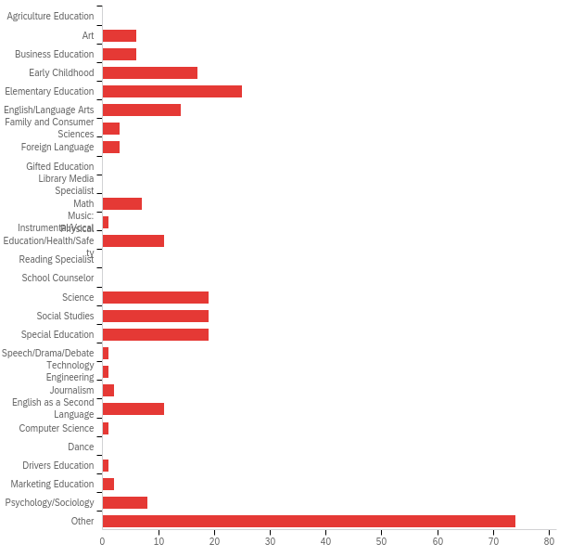

# | Answer | % | Count
1 | Agriculture Education | 0.00% | 0
2 | Art | 2.39% | 6
3 | Business Education | 2.39% | 6
4 | Early Childhood | 6.77% | 17
5 | Elementary Education | 9.96% | 25
6 | English/Language Arts | 5.58% | 14
7 | Family and Consumer Sciences | 1.20% | 3
8 | Foreign Language | 1.20% | 3
9 | Gifted Education | 0.00% | 0
10 | Library Media Specialist | 0.00% | 0
11 | Math | 2.79% | 7
12 | Music: Instrumental/Vocal | 0.40% | 1
13 | Physical Education/Health/Safety | 4.38% | 11
14 | Reading Specialist | 0.00% | 0
15 | School Counselor | 0.00% | 0
16 | Science | 7.57% | 19
17 | Social Studies | 7.57% | 19
18 | Special Education | 7.57% | 19
19 | Speech/Drama/Debate | 0.40% | 1
20 | Technology Engineering | 0.40% | 1
21 | Journalism | 0.80% | 2
22 | English as a Second Language | 4.38% | 11
23 | Computer Science | 0.40% | 1
24 | Dance | 0.00% | 0
25 | Drivers Education | 0.40% | 1
26 | Marketing Education | 0.80% | 2
27 | Psychology/Sociology | 3.19% | 8
35 | Other | 29.48% | 74
 | Total | 100% | 251

Q23_35_TEXT - Other
Other - Text
None
NA
none
None
None, but I passed the ESL OSAT
n/a
none
none
Family Life Educator - recently expired
I am not certified
none
none
iberal & Applied Studies (Applied Behavioral Science)
None
NA
n/a
MBA
AVID
None
None
Law
none
None
N/A
Working towards Sp. Ed. Certification
rehabilitation counseling
none
N/A
none
Ethnic Studies
School Bus Driver Certified
None
none. I am working on my certification tests right now.
None
none
None
none
None
N/a
none
none
n/a
None
N/A
None
n/a

Q24 - What other roles do you fill at your school? (Please check all that apply)
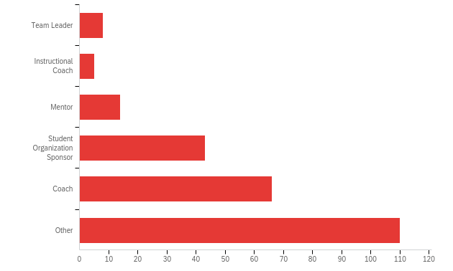

# | Answer | % | Count
1 | Team Leader | 3.25% | 8
2 | Instructional Coach | 2.03% | 5
3 | Mentor | 5.69% | 14
4 | Student Organization Sponsor | 17.48% | 43
5 | Coach | 26.83% | 66
6 | Other | 44.72% | 110
 | Total | 100% | 246

Q25 - Do you teach at a Title I school?
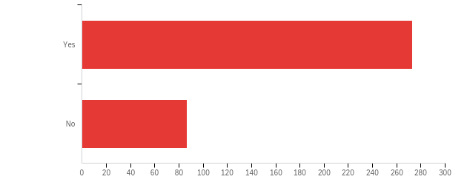

# | Field | Minimum | Maximum | Mean | Std Deviation | Variance | Count
1 | Do you teach at a Title I school? | 1.00 | 2.00 | 1.24 | 0.43 | 0.18 | 360

# | Answer | % | Count
1 | Yes | 75.83% | 273
2 | No | 24.17% | 87
 | Total | 100% | 360

Q26 - Which of the following describes your school district?
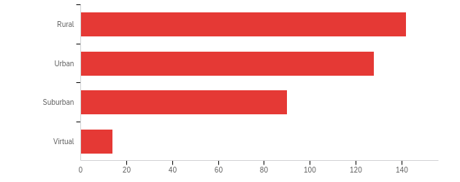

# | Field | Minimum | Maximum | Mean | Std Deviation | Variance | Count
1 | Which of the following describes your school district? | 1.00 | 4.00 | 1.94 | 0.88 | 0.77 | 374

# | Answer | % | Count
1 | Rural | 37.97% | 142
2 | Urban | 34.22% | 128
3 | Suburban | 24.06% | 90
4 | Virtual | 3.74% | 14
 | Total | 100% | 374

Q27 - As a high school student, did you participate in any programs or classes that influenced your decision to become a teacher?
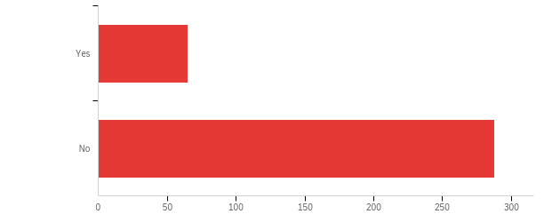

# | Field | Minimum | Maximum | Mean | Std Deviation | Variance | Count
1 | As a high school student, did you participate in any programs or classes that influenced your decision to become a teacher? | 1.00 | 2.00 | 1.82 | 0.39 | 0.15 | 353

# | Answer | % | Count
1 | Yes | 18.41% | 65
2 | No | 81.59% | 288
 | Total | 100% | 353

Q28 - If yes, please describe (e.g., Future Educators of America/Educators Rising, Teacher Cadet, etc.)

If yes, please describe (e.g., Future Educators of America/Educators Rising, Teacher Cadet, etc.)
No
Language Arts
NA
Sports
N/A
N/A
NA
none
Band Queen
N/a
There was not a formal organization. I was in band and choir for seven years. Both music programs were very strong
No
Oklahoma City Public Schools
N/a
.
Home Economics, and FCCLA (Family, Career and Community Leaders of America)
No
NA
n/a
.
n/a
I did, but none of them are what you would consider preparatory for Classroom instruction.
N/A
N/A
N/A
N/A
N/A
N/A
N/A
na
I had the best AP Biology and AP Anatomy and Physiology teacher....I wanted to be her!
N/A
I was a part of the National Honor's Society and always had a serving heart. I loved working with other people and helping in any faucet that was needed.
N/A
n/a
Na
na
...
NA
N/A
N/A
n/a
Acadec, and FCCLA
N/A
.
4H, NHS
I tutored in ELA and Science
n/a
Educators can change the world by encouraging their students effectively be successful outside and inside classroom.
FFA - Gave me leadership skills I would later use
I taught summer school as a Teacher's Assistant in the summer before my Junior year
I worked in the Pre-K class as a teacher aide.
N/A
N/A
N/A
Academic Team - Student Mentorship Program
N/A
N/A
FFA, competitive athletics
N/A
Mentor and did an internship with the preschool while a senior.
N/A
When I lived in a different state I was able to become a TA (Teacher's Assistant) as one of my elective classes. It was so much fun! It showed me how much I enjoyed it and how good I was at it. A teacher actually pulled me aside and said if I didn't become a teacher, I was crazy! That he would write me a recommendation letter to anywhere I wanted to go for college.
FCCLA- working with the headstart.
Baseball
No
n/a
n/a
Science class projects, that inspired me to love learning and education.
Four years of Spanish
Athletics
Art classes
No
NA
N/A
No
Teacher Assistant
Student Council, Journalism, Camp Fire for 10 years. My greatest influence for becoming a teacher was my 10 grade English teacher, she was amazing and encouraged me to read and read and read.
N/A
N/A
VICA, Tutoring
Teacher Cadet
N/A
Future Agricultural Education Teachers of Oklahoma
None
N/A
n/a
n/a
FCCLA, Teacher Cadet
na
KANSAS FUTURE TEACHING ACADEMY at Emporia State University
N/A
I didn't take a specific class or program, but I had some really good teachers in middle school and high school that impacted my life - I want to do the same for my students.
Future Teachers of America. Student aide in Special Education classroom
no
N/A
N/A
High School Band!
Teacher's Aide 4-H
I attended a vocational training program through Eastern Suffolk BOCES (in New York).
Leadership Class, Student Council
N/A
I had a teacher that encouraged me to teach. Psychology Class
FFA, 4-H, Athletics
Student council
Leadership, tutor, big brother big sister
N/a
None
None
None
Music and theater
we did not have any classes that were available such as future educators or educators rising however I did have many teachers that took the time to work with their students and that impacted me greatly.
N/A
N/A
These programs did not exist in Puerto Rico when I went to school
N/A
n/a
I took Band, Future Homemakers of America, Student Government and upper level Math and Science classes. I knew that I wanted a college education, but I wasn't sure that I wanted to teach until later in life.
N/A
N/A
No
it was no.
n/a
Sports,
N/A
No
High School Art Classes
None
FFA, Student Council
N/A
NA
AP History
N/A
No
Peer Assistance and Leadership Skills (mentoring elementary students)
N/A
N/A
N/A
Band, under an excellent Band Director
FFA
I already knew I wanted to be a teacher before I started school.
N/A
N/A
n/a
All State Orchestra
N/A
Yearbook and newspaper
none
no
Kansas Thespians Troupe #3540
N/A
N/A
Future Educators of America
N/A
NO.
N/A
None
Future Educators of America
tutoring
N/A
Future Educators Association
I was studying in Brazil. I had all the support there to become a teacher.
Theatre

Q29 - Do you plan to remain employed as a teacher in Oklahoma next year? If so, please list up to 3 reasons you plan to stay. If not, please list up to 3 reasons you do not plan to stay.

Do you plan to remain employed as a teacher in Oklahoma next year? If so, please list up to 3 reasons you plan to stay. If not, please list up to 3 reasons you do not plan to stay.
I plan to remain employed as a teacher because I love my students and their families, I feel I am making a difference in my students' families' lives, and I want to impact Oklahoma's future by influencing young Oklahomans and their families!
Yes, I will the reasons are: 1. I like to teach 2. I like students 3. I want to be somebody who can influence someone's life
Yes! Small town Small district Close to home
Yes, I plan to work as a teacher in Oklahoma next year because of a strong administrative support, community, and a positive environment.
Yes, I love the kids. I enjoy teaching. I love literature and art.
Yes 1. 4 Day School Week 2. It allows me the same schedule as my husband who is also a teacher at the same school and as my 2 children who attend this school . 3. The kids. I love the kids.
I enjoy The Honor of Shaping and Co-Molding young Brilliant minds. Teaching is a Hugh part of my Craft,Skillset and Persona. Teaching is Educational and I Love Learning and Want to Empower the Gift of Learning to Countless others.
Yes. Hours, team I work with, and the flexibility I have
Yes. Same schedule as my personal children. Personal satisfaction-I feel like I'm making a difference.
Yes. 1. Help shape our future generations. 2. Encourage better education for & among the kids. 3. Make a difference in someone's life overall.
Yes. I love teaching students to read. I love the support from Instructional Coaches and coworkers. I enjoy getting several small breaks to rejuvenate.
Yes - I enjoy working with high school students. I feel that I have the potential to be an effective teacher. I want to support the growth of my students, school, and community.
Yes, I truly love working with students and helping them to grow each day. I love learning every day myself.
Yes. It is rewarding. I have built strong relationships with students. I have built strong relationships with teachers.
Yes, I plan on remaining employed as a teacher. I was an early Early Education major prior to getting my degree in Sociology. I transferred colleges after 3 semesters of student teaching (due to personal reasons), so I was unable to complete my education degree at Valdosta State. I always planned on returning back to the classroom, but I ended up working in child welfare for the State of Oklahoma for the last 8 years. I am so grateful for my experience in child welfare, and my perspective I now have because of the children and families I worked with over the last 8 years. 1. I love the fact that I have the ability to make a difference with not only my students, but the student's family. 2. Sharing my love of learning. School was hard for me, but I had good grades. I want to show students that if you work hard you can achieve anything. 3. The love I have for my students. It is amazing what a child can do/become when they have someone who loves and supports them in their corner.
I am undecided. I do not feel that today's students are getting the best education possible. Technology is both helpful and harmful in this aspect. It seems that students have a great deal of difficulty in formulating thoughts or arriving at answers using critical thinking without first being able to check their phone or iPad. It is very frustrating to see the lack of fundament skills being taught to students, the lack of concentration students seem to possess, and the emphasis put upon sports and extra-curricular activities that take students away from classroom instruction.
1. I love the community I live in. 2. I love teaching. 3. I like the school district that I am teaching .
Yes For the children Love my co workers Good boss
Yes
I am teaching and coaching at the same school as my son I feel I am making positive influences on some of my students' lives I enjoy teaching young people
I am the caretaker of my parents, who live in Oklahoma City. I will be staying here and hopefully working in my field of expertise. This is actually my 24th year of teaching, just my first year teaching high school. I love Oklahoma!
Yes.
Yes: personal goal fulfillment, work/home balance, job stability
Yes, I plan on remaining employed as a teacher with Oklahoma City Public Schools because I enjoy educating students, inspiring others to be their best and being a positive influence in others life.
Yes I enjoyed it, loved the kids and the faculty
Yes I love my job and the small town community that our district is in. Oklahoma is where I have lived my entire life. I want my kids to grow up in the same county that I grew up in.
I plan to stay because I love my job, I love the multiple mentors/Friends/Family I have met on campus, but most importantly I love the community. I feel supported by my director, she has helped me overcome several challenges in this first year of teaching.
I plan to teacher in Oklahoma next year because I want to continue the path to becoming an excellent teacher. I want to clear my preliminary credential. I want to earn a credential in ESL. I want to earn my masters in Early Childhood Education.
Yes I love working with children, I like my building, there is a great need for teachers.
Yes, I do plan to remain a teacher in Oklahoma for the upcoming school year so I can continue to develop relationships with my students, gain additional experience in the field of education for other opportunities outside of the state of Oklahoma, and to remain closer to family.
Si
1. Love My job 2. Love teaching music to others. 3. Great benefits (schedule, great Admin, great co-workers)
Yes, I enjoy teaching my programs I enjoy the work schedule I want to be apart of the opportunities Okmulgee is giving its students to get a head start in life after highschool
I am Praying that I will be employed as a teacher in Oklahoma for the rest of my career. I have finally landed the job that I have been preparing for my whole life and throughout my educational career. With my understanding and fundamental training in education and child development, I know that I will be a valuable asset to the community and developing students in my classroom. My position this year at Irving Middle School has allowed me demonstrate my understanding and respect for individual differences, diverse cultures, etc. and has allowed me to demonstrate how to effectively and respectfully communicate with one another in a positive manner, which is paramount in creating a positive learning environment that is supportive to individual as well as collaborative learning. Lastly, my experience in educational research and project planning has equipped me with the tools and drive to learn, create, and instruct grade appropriate content according to state and district guidelines and parameters.
I love introducing students to old/new literature. I want to continue encouraging students with obstacles to set and achieve goals. I want to help the youth in my community succeed.
Yes, 1. Its a job that I feel confident I can do. 2. A job I can improve in and grow. 3. I can't have a harder year than this first year.
I plan on returning next year. I only have one reason. I like working with unprivileged youth and right now this is how I feel fulfilled doing that.
Yes. 1. The love of learning and passing that on to my students. 2. To create a future generation of avid book readers. 3. To prepare my students for college or trade school.
Yes. I like my job. The schedule works well with my kids who attend this school. I will be working towards my Master's in this field.
No. Too much work for too little pay I hate epic charter school's model I'm staying home to be a mom
My provisional certification requires that I teach in the Elementary capacity until I become fully certified. I will stay in my current role until my certification is finalized. Then, I might explore options to teach in the field of my degree.
This is the best school district to work for. I love my current position. No intentions of moving again.
Yes, I plan to remain employed as a teacher in Oklahoma because: I find the work to be rewarding. I like that the work is challenging. I like the overall school work schedule.
I enjoy teaching but for all the work, certifications needed, and requirements to fulfill, teachers are not paid enough. Summers are for second jobs to be able to pay make a descent living. I'm not sure if I will stay in the field of teaching. I don't have much of a choice to stay in Oklahoma or not because of family.
I have realized teaching regular school subjects is not a passion of mine. I had too much on my plate as a first time teacher. The pressure behind the students succeeding and doing well, when a lot of the time I had very little control over whether they did sufficient work or not. That then being reflected on me, when I know I am doing everything I am told to do was very demoralizing.
yes It is where I live It is where I was born and raised My family is all here
Yes. I love the school I work in and my principal. The district has been wonderful and supportive.
Yes. Flexibility, supportive principal and work mentors, enjoy my school
I am unsure at this time
I plan on remaining a teacher, but only for enough years to get enough experience to work somewhere that actually cares about teachers. Teacher pay and benefits in Oklahoma are abysmal and pathetic at best. My brother has no college degree and a computer certificate and makes more money working far less hours than I do. The only reasons I would stay are because I like teaching and it is close to home. Other than that, I can make more money elsewhere and with half the stress. Oklahoma makes it very difficult to become a teacher, the hurdles seem artificial and designed to keep teacher numbers low.
Yes The people I work with My students and athletes The location of school
Yes! I love my job with Epic! I love my SPED kids and teaching live Biology classes!
Yes, I enjoy being able to impact and build relationships with the kids. Some students that struggled in the beginning are starting to come around.
I live here, my children have been going to school here since they started school, also I am not fully certified yet.
I plan to stay in Oklahoma because I choose to raise my family here. I love this area. I work in the best school district in the state and I feel fully supported by my admin team and my grade level team. I love teaching. I did not come into this field with rose colored glasses on. I knew that a lot of my time would be dictated by testing, data collection and collaboration, so I don't feel disillusioned as many first year teachers feel.
I love teaching prek. I love the team I work with. I want to learn more and grow to become a better teacher.
Yes. My parents and children are here in Oklahoma. I also grew up in Oklahoma. The only thing that would convince me to move out of state is a much higher salary.
Yes My family is in Oklahoma. I love teaching! I love that they are moving to the science of reading and offering LETRS Training!
Yes I plan to stay employed as a teacher in Oklahoma next year. I plan to stay because of the positive teaching and learning environment that is displayed here at my school, the students, and the positive family community that is built here at the school.
Yes. I love the kids. I love to teach. I love the staff I work with.
Yes. 1. It is gratifying to see students wanting to learn and that in turn makes me excited to come to work each day. 2. The administration is very supportive in terms of counsel and direction. 3. The staff and colleagues work extremely hard to help each other succeed.
I love my school and coworkers. I feel like I have finally found where I “fit.” I enjoy seeing students “I get it” moments. It is rewarding to see all of that hard work finally pay off!
1. I love teaching children. 2. I love having summers off. 3. I don't have many alternatives for a good job in rural Oklahoma.
Yes, Because I enjoy learning and teaching. I also know that schooling can be tough for those with disabilities and as someone with a disability myself I want to show them that anything is possible if they put their mind to it.
Yes. Seeing students go from struggling with new concepts to mastering them is very rewarding. The administration at my school is incredibly supportive and helpful. Working one on one with students and their families to reach success is very fulfilling.
Yes, I am not planning on leaving the profession, I enjoy my coworkers, and I enjoy my school atmosphere.
I think so. I like the schedule. I like guiding and engaging children in learning. I enjoy doing something meaningful. I do not like how the administration exhibits nepotism towards wife that is a senior but terrible/far less superior teacher. The pay could be much much better. Administration in my school is never available because they are also coaches/etc.
yes
Yes, 1) I enjoy teaching 2) I really like the schedule 3) gives me more family time than my previous career.
Yes. 1. I feel like I am making a difference 2. My administration is very supportive of teachers. 3. I enjoy teaching.
I plan to teach next year. I plan to teach next year because I enjoy working with my team, I love working with my community and I enjoy teaching.
I would love to. I believe that preparing children for the future is important. I believe my area of study teaches important critical thinking skills. I love being able to combine my passion for science with my enjoyment of working with young people.
yes. I love the people I work with. I love my students. I know my "Why".
I like teaching and helping the students. The health benefits are good. The time off in the summer is the third reason.
I live here Teaching is my life I need to work
I find the career rewarding. If i were to say no, It would be because the pay is terrible.
No, only because I am moving back to my home state: VA. I very much enjoyed working at CAMS! I loved the staff and the students! I just want to be closer to my family!
Yes. 1. I enjoy the personal fulfillment teaching brings me. 2. I have a very supportive Administration, who helps me be successful in the classroom and in our Minco FCCLA chapter. 3. The hours.
yes, 1. This is where my family lives 2. I don't want to live elsewhere 3. My friends live here
yes I have a passion for teaching. I love these kiddos. Teaching is more than a job, it is a lifestyle and I love it.
Yes. 1. Love working with the students. 2. Positive work environment. 3. Summers off.
I have been 10 years in Oklahoma. I live and work here. My husband goes to school and and my kids too. I have to stay in Oklahoma.
Yes. I plan to stay because I enjoy my position as an ELA teacher. I enjoy the age range of students I teach. I also enjoy the district I work for.
Yes, I love the students and getting to be around them all day. I like the feeling when they gain the confidence learning a new skill. I like making a difference in the lives of children.
I do plan to remain employed as a teacher in Oklahoma next year, however, I may decide to go to a different state in the future. I will stay due to: 1. Staff Relations 2. Insurance 3. Student Relations I would leave due to: 1. Lack of support with student troubled behaviors 2. Lower Pay 3. Education Standards too Vigorous
Yes. I love teaching! I am excited for a new school year after all the things I learned from teaching for a year and trying again with that knowledge. I am excited to continue growing in this career.
Yes
Yes, I plan to remain teaching in Oklahoma next year. First, I love this state and this community and want to encourage students to love and represent it well. This district is doing big things and I'm excited to be part of them. Teaching here has filled a space in my life I didn't even know needed filling.
I’m not a quitter. I loved the experience. I want to be someone the students can comfortably talk to about things that they can’t share. No one needs to bottle up all the emotions/experiences they’re going through.
Yes I plan to continue to be an educator. I love teaching children. It is rewarding job.
Yes I plan on staying. I love teaching and seeing my students grow in their education. I love who I work with, we work really well together.
Yes. 1. Continue path to certification within Tulsa Teacher Corps 2. Continue to help educate youth. 3. Continue to coach.
Yes. I feel like even though elementary education is not my area of study/degree, I have found my true calling. I truly enjoyed my coworkers and my students. Lastly, I feel like I'm making a difference.
Yes I plan to stay in Oklahoma and teach next year. 1) My family, and myself, are from Oklahoma. 2) I plan to stay in Oklahoma. 3) I plan to stay in teaching.
Yes. Work/family balance; love to coach; great community at Collinsville
yes I enjoy teaching I enjoy my district i enjoy my coworkers
Yes. I want to be a positive influence in the lives of the students I teach, my favorite part is seeing the children learn and grow, there is still so much I can learn and give back to my students.
Yes, I have enjoyed making an impact on the students. This profession has also challenged me and pushed me to grow in new ways. I also feel supported and encouraged at my school and enjoy the positive work environment.
I love teaching! I love BA! I love Rosewood!!!
Yes, I want to teach again because I love the impact I made on kids, the progress I have made as a teacher and I have noticed how amazing teaching is.
Work/life balance Kids are fun and keep things interested Admin is very supportive
Yes, - I work with a great group of teachers. - I work at a great school that support me. - I work with a great team of 5th grade teachers that support me and take my ideas seriously.
yes, because I enjoy the kids and love the environment Im in
I do not plan to stay. 1. Administration provides no support. 2. Work cannot be completed within contract hours, overtime is inevitable. We are already not paid nearly enough. 3. I feel physically unsafe at my school.
Yes. 1. I live in the area. 2. I enjoy those that I work with in the district. 3. Oklahoma is amazing!
I love the school I teach in. My students are the best part of teaching. I enjoy teaching.
I will be taking a non-teaching position next year to fulfill a role that is needed for my school district.
Yes. I enjoy interacting with the students. Science has a place in my heart and I want to encourage students to enjoy it. I find teaching to be a fulfilling job.
I do plan to stay employed as a teacher next year: I love getting to work with kids, and build activities to help them learn I want the stability of a second year teaching to build work experience I want to get an elementary teaching license as well as teaching ESL certificate and would like to work while doing those.
3 reasons I would stay 1. Making a difference in youth 2. The schedule 3. Coaching opportunities 3 reasons I would leave 1. The pay 2. State certification process and red tape 3. Lack of Coaching opportunities
Benefits are nice Time off is essential Flexibility
No 1. I was grossly underprepared for teaching students during this pandemic. As many, many other teachers can tell you, this year has been the worst out of many for student behavior. We cannot do any differentiation with our classes. We cannot incorporate any different methods without our classes devolving into chaos. I've had students chase each other with scissors, throw desks, etc. all because we tried to play a Kahoot to practice and learn instead of a regular, rigorous structure. 2. There is no amount of professional development or training that can help with or prepare for what is coming. Teachers are leaving in droves, because while we are forced to continually take on more, our pay remains stagnant. I can take my one year of teaching experience and get a job that pays double that is far easier than the job I do now, and far less draining on myself and my own family. 3. I love teaching, but this year, I have not taught, I have babysitted instead, and everyone seems to be fine with that except me. I have over 30 students out of a 109 student load that haven't turned anything in all semester. They haven't completed any work. And yet, they still show up to my class, disturb the learning of those around them, and nothing is done. Parents and admin have been notified. Nothing has changed. These students do not care to learn, and the parents do not care if they learn either. They just need the childcare so they can go to work and pay bills. As a parent myself, I almost understand the sentiment. My kindergartener right now is taking standardized tests all of this week. And for what?! Most kindergarteners can't even read! And what are we going to do with those metrics? Mountains and mountains of research shows that standardized testing is not good for students, and yet we keep piling it on. Studies were just released that showed that academically driven pre-k programs were actually counterintuitive to academic growth by the time students made it to 6th grade. And yet, we keep going. As teachers, we were forced to go to 4 years worth of schooling that taught us how to look at the research and do what's best for students, but when it comes time to do so, we aren't allowed. Instead, we are instructed to STAAR test them every 2 weeks because their reading scores are so abysmally low, surely re-testing them over and over will help. We know these things don't work, but teachers who show practical data and research aren't listened to or respected. At this point, quit calling us professionals and making us do so much extra training and development and start calling us babysitters. That's how we are paid and that's all we are expected to do.
Yes, admin support, curriculum support, staff support.
Yes, I love being a teacher to children. I have enjoyed seeing the childrens growth in class with my subject. I enjoy my colleagues and work environment.
Family, convenience, and affordability
Yes, I plan to continue teaching. I enjoy getting to make an impact on the children in my community. I appreciate being on the same schedule as my own children. I want a career that helps me prepare for my retirement.
Yes. I love teaching students. The community. Being able to mold and grow students.
1. I work with one of the most supportive and fantastic schools! Everyone is apart of the team! 2. I love the students and the classroom environment! Small classes = more personalized learning. 3. I love being a teacher in general! It makes me happy! It was my dream job.
Yes, I live here, I am currently employed in Oklahoma and I enjoy the school I work for.
I want to make a difference I enjoy it Income
1. I love teaching in Norman, Oklahoma and helping meet my students goals. 2. The Norman schools are always looking for ways to get better. 3. I highly respect my schools administrators.
Yes. 1.I like the working environment in my school. 2.I want to get more teaching experience. 3.I like teaching in Oklahoma.
Yes. 1. I truly love working with the students; it is challenging every single day, but I also see so many of them growing and thriving and they make my heart happy. 2. I am fortunate to work at a school with a great admin team who is very supportive of teachers. 3. I want to help Monroe thrive as a middle school and our principal has a great plan in place to get us where we want to be.
yes The soft skills I teach the children. I enjoy Family and Consumer Sciences. Students need FCS.
Yes, I would love to. 1. I have an amazing team of admin and teachers in my department that welcome and support me. 2. I am fulfilled each day as I instruct and support adolescents through a challenging time in their life where they are figuring out who they will be. 3. I want to continue to grow and improve as a teacher and need more experience to do so.
Enjoy working with children. To empower the future generation to become all that they can be. To open the door of opportunities and potential, that children may be able to accept the challenges that each day offer.
My coworkers My students
Yes. I need the paycheck. I want the same schedule as my husband. I am not interested in other jobs in my degree field.
Yes I live here No other reasons. Education in this state is a horrible mess. Very bad situation.
Yes Building connections in Oklahoma Connecting with families in the community Wish to see community improvement
Yes, I do. - Same schedule as my child. - Passion to educate others. - I love being a teacher.
No, 1. I'm putting my time and energy into my business. 2. Getting paid one time a month is not for me. 3. It is primarily discipline and grading, meetings, emails than teaching
Yes. I care about students. I enjoy the teaching schedule. I like my co-workers and my school.
Yes To finish TTC program
Yes, getting to work with adolescents, summers off, and part of the local community.
Yes 1. Good team 2. Supportive administration 3. Good schedule
N/A
Yes. Because I love teaching. The leadership supports me. My peers support me.
Yes, I want to continue to teach next year as a Special Education teacher. I have always enjoyed helping others learn. I started out in college in the education program, however my life went in a different direction with college and family. I have found over these last 13 or so years everything has brought me back to where I have always saw myself being a teacher. I enjoy being around the kids and watching them discover things they could do that they did not think they could. I love seeing their face light up when it finally clicks in their head. When they feel that since of accomplishment in their work. Watching them put in hard work and then seeing hard work pays off and they can see that the end results shows how much effort they put in.
Absolutely! There is great need and children need people who are willing to love and help them grow. My administration is incredible and they are so supportive. I feel at home in the classroom and love watching children grow.
No. There is no room for growth. There is no incentive for greatness. I don't have any hope that this system can be fixed.
It is my dream to continue teaching English. I want to make a difference. I hope to encourage students to read more, it is the foundation for all success.
yes. finish getting certified. student population needs teachers that won't quit on them. staff at school is very supportive and dedicated.
Yes. Enjoy working with kids. Love coaching. Like making a difference.
Yes The schedule follows my children's schedule. I value the school's leadership. I love the kids that I work with.
Yes, I want to continue to coach and make an impact on students.
Yes, but is it dependent on my wife's remaining time at Oklahoma State University. 1. I really enjoy the community at my school. The teachers I work with are great and support everyone around them. 2. I am using my time teaching in Oklahoma as great teaching experience before my wife and I move.
Yes Community Support School Support Students
I do not know. I’ll prepared by district/schooling. The pay is inadequate. Little to no support
Yes I do. The children are wonderful. I am good at teaching. I like to make a difference on children's perception of learning and growth.
yes Great school to work for Great kids to mentor and teach great teacher mentors
I love teaching. The opportunity to grow the STEM program. Working with TSA and Oklahoma Career Tech advisors.
1. Working with the students. 2. Watching the students learn and grow. 3. I get to have the same hours as my kids.
yes - I love my job, staff, and community at the district I am in
I like my co-workers I like the area I like coaching
Yes 1. I enjoy teaching students 2. I would like to be a part of the success that some students receive at their graduation 3. It is satisfying to be a positive influence and guide for students that are striving to be in a position to obtain a professional career such as Military, College, or any other professional career.
Yes, I enjoy working with children, having a stable job, and working with a team.
Yes, I have roots in my community and the students here. I live here and have a home here. I was born and raised in Oklahoma and I plan to do the same with my own children.
I hopefully will still be employed in Oklahoma next year, but if my only option is to remain in Mid-Del I will be leaving the profession.
Yes. I love my students. I feel like I am making a change in their lives. This is my purpose.
Yes. Love teaching in all aspects. Love the school, staff, and my coworkers in my grade. Have no plans to go to another career. Live and from Oklahoma and no future plans to move.
Yes I love to teach, college or high school
Flexibility for a working mother Time off for breaks to be with my own kids Seeing each students growth
Yes. I love teaching, and I love the staff I work with. Teaching is very rewarding and I have built long lasting relationships with my students.
I have enjoyed teaching so much, Oklahoma is my home, and I love my boss.
Yes, I love the age group I am teaching. I enjoy the the staff here. I enjoy the work schedule.
Yes, 1. I love to teach. 2. I enjoy working with younger students. 3. I enjoy seeing the students catch on to the curriculum. I am having difficulty passing the OSAT teaching certification tests because of test anxiety. That is the only obstacle that could keep me from teaching.
I enjoy working with students and helping them experience success.
I plan to stay employed as a teacher next year so that I can continue to make a difference in students' lives. I want to create a safe, positive environment that fosters a love for learning, and continuing to teach would allow me the opportunity to navigate that environment.
Yes
Even though the passion to teach came later in life for me, I absolutely love being able to make a difference in a child. I love to teach children scholastically and help them build character that will stay with them forever. I am excited to get up every morning and bring the type of energy kids crave and thrive under. Even though I did not go to college to be a teacher, my heart and passion could not be stronger for these children.
1. I plan to stay because this is home. 2. I plan to stay because I see the need in my community. 3. I plan to stay because what I see what I do is making a difference.
Yes I feel I am making a difference at my school. This is exactly why I took all tests--to be able to get into a school to help struggling readers. This is a great school/school district.
yes
I will stay due to the support my administrator has shown me, I will stay due to the support of my co-workers, and because of my love of teaching.
No, I will be a special needs Para
Yes I plan to remain a teacher in Oklahoma. 1. I have a wonderful principal 2. I enjoy my position greatly 3. I feel like I can and have made a positive impact on students lives.
Yes, I love children, I find being a teacher, I love all the challenges
Yes I enjoy teaching I enjoy learning I enjoy the flexibility
Yes To make a difference Help students succeed I love what I do.
Yes. I will love to remain as an okcps educator because I gain a bond with all student in the school for all grade levels. I will enjoy having the up coming third grade students in the class this fall. I love the friendship that I have built with in Britton environment.
No. 60-70% of students don't care about their education and don't have parents that care either.
Yes. I changed from teaching at OU to the K-12 system. I love the variety of courses I get to teach here. I enjoy the faculty and administrators in this school system. I am rewarded by working with students all day, every day.
I love working with special ed kids. I love the schedule. I love the feeling of working in a school.
Yes
Enjoy my job Enjoy Subject Area Small Classes in district
1. I love the school district 2. It is a family atmosphere with my co workers 3 The students are amazing
Yes, 1. I love teaching, both academically and behaviorally. 2. I want to continue to build relationships and community with new students. 3. I want to continue to learn from our subject materials and from my students.
No: 1. Classroom behavior 2. Low pay for work expected 3. Unpaid work hours to be able to complete the required job
Yes. I love being an advocate for my ELL students. The schedule is great for a single mom. My administration has been very supportive of me as I'm learning how to be an effective educator.
yes
Bartlesville School District Baseball Math
Yes. I like being able to impact the lives of the next generation of society. I enjoy helping young athletes accomplish their goals. I don't feel like I have to get up and go to "work" everyday. I enjoy being around the kids and watching them develop.
Yes I plan to remain employed as a teacher in Oklahoma next year. The district I am employed is really great and supportive. The teachers in my district are amazing and have helped me so much this year, especially my fellow special education teachers. The students are awesome and have made my first year teaching one to remember.
1.) Yes 2.) - I enjoy engaging with my students and their families. - I want to make an impact on students lives in all aspects, not just in their education. - I love the relationships I have formed with my coworkers.
Yes - I like teaching I want to gain the retirement I have a child in k-12
Yes! - NPS is a very supportive district. - I love my work family! - I feel supported by the state department of education.
YES.
Yes I plan to remain employed as a teacher in Oklahoma next year. 1. Teaching is what my degree is in. 2. I enjoy the school I am employed at. 3. I enjoy teaching.
I love helping students who want to learn.
As of now yes.
I plan to stay to help the students, the coworkers I work with deserve my respect and loyalty, and I want to stick with education for 2 years before making a decision.
Yes. Love the culture. Family environment, as far as co-workers Enjoy teaching kids
1. I have excellent administrators in my building/district who provide exceptional staff support. 2. I love the kids I work with daily. 3. Pay is well above the state minimum.
Yes 1. It was my original plan to teach and I have met one of my life long goals 2. Enjoy working with students 3. Students need the help and our schools have teacher shortages
Yes. 1. I want to continue to make a difference in the public school system. 2. The breaks we receive throughout the year. 3. My coworkers make it a great experience.
Yes: Just moved, have a community here, and need to give this a chance.
Great mentor, family lives here, great school district.
I plan to remain employed as a teacher in Oklahoma for the 2022-2023 school year. Here are 3 reasons I plan to stay. 1. I love my job. 2. What I do has purpose and makes a difference. 3. My kids need me.
yes, My family lives here. I love my job, I enjoy working for the administration
yes. kids, experience, time off
My extended family resides in Oklahoma. I love teaching in my current district and it's affordable to live here.
Yes I do I got into teaching to play an effective role in the lives of young people, Sallisaw Schools has given me the opportunity to do this. I enjoy what I do and I want to continue to pursue my teaching career because the rewards are worth the effort. I made a career change and it has paid off for me for the purposes of not only being a greater influence in the lives of young people but is has also given me the quality time that I have needed with my own family.
Yes. Enjoyed interacting with students and faculty Developed relationships with players Felt it was a positive year
Yes, I plan on remaining employed. I enjoy being in the classroom with my students, watching them grow both academically and as a person, and teaching all of the new concepts.
Yes, I love teaching.
Yes 1. Making an impact on students lives is meaningful to me 2. I like the community built into a school as a workplace 3. I get to teach music, which is my passion
yes, I do plan on reaming employed as a teacher in Oklahoma. I love the atmosphere of the school and all of my coworkers who are very encouraging. I like getting to help little ones learn and being able to watch them achieve their goals is an amazing thing. I like getting to watch them light up when they learn how to read.
1. Good People 2. Support from Admin 3. Great place to live
Yes schedule students community
I plan to stay because I love teaching students It is a rewarding job to educate our future I do my job with passion for change in student's lives and want them to reach their full potential
Yes, I enjoy working with the students. I love the school district and how they support me. I enjoy the profession.
I enjoy my students, I want to become a better educator, and help my students learn.
Yes.
Yes 1) I love having the opportunity to mentor our future generation. 2) almost everyone I have met at the school are welcoming and enjoy teaching, makes for a great working environment. 3) The school schedule is a much better schedule for my family and church life.
Teaching has not been good for my mental health due to the lack of staff/substitutes, the pay and how teachers are treated in general.
Yes: 1. Love of teaching 2. I find meaning in my work 3. I appreciate seeing growth in my students
I love working with extraordinary children helping them make gains and achieving progress! I am very happy with my employer and my position in Epic. This is truly what I was meant to be doing!
enjoyed my time at this school feel supported by the administration do not plan on moving - have a family here
Yes I plan to return as an Oklahoma Educator 1. I enjoy working with students 2. The extra income is helpful for my family 3. Being an educator I am able to work but still have days off with my children that are in school.
Yes. I enjoy the kids, teaching the material, and getting to know my fellow teachers.
Yes. I enjoy teaching. I feel drawn to the field. I believe I make an impact in students lives.
I want to motivate some of the students the same way some of my secondary teachers did for me. We need more responsible people willing to go the extra mile to reach the reachable. I am good at something I thought I would never do professionally.
I plan to stay because I like my schedule, control over lessons, and building support.
Yes. I love the students. I love the staff here in my school district. I love helping my special education students to learn. They are incredible individuals and I feel very lucky to be in the spot that I am in. I hope to be rehired here.
Yes Great community Positive environment Work well with others
yes 1) I love seeing children learn. 2) I love working with children. 3) I want to see children receive a quality education.
Yes. I plan to stay because I love what I do. I am passionate about English and especially literature, and I love to make literature as fun and interesting to others as I believe it is, especially those who are apprehensive about it. I love to help others, and watching a student catch onto something they have struggled with is so fulfilling. I will finish my Master's in School Counseling and Clinical Mental Health Counseling in December of this year. I would like to teach for at least 5 years and then being my journey in counseling.
No. I have inadequate training. My daily routine includes dealing with behavior problems far more than actually teaching. The pay structure.
Yes. I don't plan on moving out of state. I enjoy working for the school I do. I enjoy the students I serve.
Yes. I enjoy the interaction with the students and trying to help them understand a difficult subject for them. Math.
yes 1. I love the students and the impact that I am making in their life. 2. I love the teaching community that I am working with. 3. I want to continue investing in students so that they can reach their greatest potential.
I enjoy working with children. The job is not as daunting now that I have had some experience. I am passionate about science and want to pass that passion on.
I plan to stay because of the following reasons: - I know that, even though this job is difficult, it is worth it. - I know that there will be many opportunities to change student trajectory - I enjoy the time with students.
Yes. I enjoy working with students who have special needs.
Yes 1. I love working in education, especially being able to work with children. 2. Teaching has given me a purpose and although I came into it knowing it was a passion-driven career, I have been overwhelmed at how much it feels like it's what I was made for. 3. Oklahoma has always been my home and teaching the future decision-makers of the state is very empowering.
Yes. I love the schedule as a mother. I love my students, and the growth I see in them from the beginning of the year to the end. English is my passion and it excites me to share that with the next generation.
Yes. I plan to stay in education because I love what I teach, like the hours and time off we recieve and find the work rewarding.
yes 1. I enjoy getting to teach students about the art process and it's history. 2. My students seem to enjoy having an art outlet to create. It is something they did not have previously. 3. I enjoy my building and it's administration.
Yes. having been a firefighter before teaching, I feel I am able to continue to have a direct impact on the community which I serve. I enjoy the development and relationships I am able to make with the students and athletes. I continue learning and bettering myself as a person daily in the environment I am in.
Yes. 1. Great area 2. Great community 3. Enjoy my job
I enjoy teaching at my current school. I have settled in Oklahoma. I adore the students that attend my school.
I would love to stay employed by my current school district. I love teaching, and helping students grow in the classroom. I enjoy seeing my students have their. "AH HA" moments where something clicks. I enjoy the interaction and feedback from the assignments and activities we do. I really want to stay due to seeing how I am making a difference, and seeing how my students are learning from me.
Yes, 1. I enjoy teaching students 2. Building healthy relationships with students and staff 3. Having a positive impact on the community
Committed to school Plan to teach until daughter graduates Hope to become a better teacher with additional experience
Yes. 1. Opportunity to make a difference in my community. 2. Wonderful co-workers and great work environment. 3. I enjoy what I'm doing.
Yes 1. help students 2. School Family 3. Good schedule
Yes, 1. I relocated my family here. 2. My parents live nearby. 3. My husband also works for the district.
Yes, I love teaching children. It is a very satisfying job and it has always been a dream of mine. My principle here at the school is amazing and has giving me the support I needed as a first year teacher.
Yes, the low amount of teachers, the kids, the small town feel
1. My husband is a partner in a business in Oklahoma. 2. I have family in Oklahoma. 3. I am having a positive experience with an alternative teaching program.
Yes, healthy working enviroment, quality or administrator, and enjoyment of content.
Possibly. I am exploring all areas of teaching and look outside of the field. I have to do what is best for my family and support them financially.
Yes, 1. Steady pay 2. Insurance 3. Snow days
Yes.
Yes, I enjoy teaching, I like my school, and I enjoy having summers off.
Yes, Like teaching Like working with the young people Keeps me active in learning for myself
Yes. I have taught both as a college professor and now as a high school educator. I enjoy having the opportunity to build relationships with my students, which was a key component that was missing teaching general education courses at a four year university. In addition, there is always room to expand and improve my curriculum, and I enjoy staying current in my field and utilizing my knowledge in the classroom. I am teaching in the same district in which I am planning on sending my own children, and I love the ability to be on the same schedule as them.
Yes Enjoy the job as a whole. Enjoy working with children. Feel like I can make a difference.
Yes, because I like being a teacher, I like the pay/school, and I like my coworkers.
I love teaching and watching kids grow Fun environment
Yes. Treating the school as a mission field and continue to speak into the lives of young students, using the classroom as an opportunity to have a captive audience to teach core values and foundational rocks to set them up for success later in life, and to lead with a servant's heart toward the students as well as my fellow teachers/staff/administration.
Yes, I live here
Yes I feel called to teaching Math at this school. I am just getting started. I will only get better over time.
I want to apply what I learned this year to building a better, more productive second year. I will have the opportunity to teach the subject I most want to teach and which most closely matches my education and experience. I like working with my coworkers and team.
Yes. I enjoy the students that I am working with. I liked the subject I was teaching. All of my colleagues were their to offer any help if I needed it.
Yes, I plan to continue teaching. I enjoy seeing the students discover their own abilities in both the classroom and their sport. I have an incredible work environment and great coworkers. My principal and mentor are both very helpful in critiquing my work and encouraging my growth.
No 1-The fact that most (75%?) of the students I teach have no desire to learn or do the work. 2-No support from Administration on student behavior issues. 3-All the extra, non-contract time hours needed to be spent co comply with requirements not directly associated with the subject matter that I am teaching. (Behavior, EL, Special needs)
Yes - Switching to different grade. - Finishing certification through TTC. - Family reasons.
Yes I plan to remain employed as a teacher in Oklahoma next year. I love teacher and I realize that my experience and expertise is needed along with my passion.
The students need teachers who are passionate about their future. I enjoy the process of learning The schools need teacher's who care!
Yes - Enjoy teaching - Want to make an impact in the community - Want to learn more about how I can assist families help their students be successful
Yes Additional teaching experience Learning more about district policies procedures as it connects to teachers Future leadership positions I enjoy being in the classroom and teaching
yes. The students. The science The job security
I like my job. The staff at my school are easy going My coach at school is very helpful
I was a paraprofessional for 7 years prior to this year. I love what I do and becoming a certified teacher allowed me to fall in love even more that I will be completing a M.Ed next school year. The kids are amazing. I love my coworkers.
No, I want to move back to where I grew up, and I also want to work in a place where I am valued more by the administration.
Yes. I was led to teaching for a reason, and I feel that I need to pursue that. Having an impact on the lives of kids that need it, shows that what I do is worth it. I believe it is worth it to give this profession an actual try but to do that I have to give it more than one year.
I plan to stay because I want to serve my community, I enjoy the school I am working at, and I really feel like I understand what I am teaching now and can do even better next year!
1. I love teaching in the State of Oklahoma. 2. The children are the reason that I teach. 3. I Love teachinging.
Yes. I live here, I want to have an impact where I live, I like the people at my building.
Yes. 1. I want to continue teaching and use what I have learned/learning an pour it onto my students. 2. I have built a great relationship with students, parents, and staff. 3. I feel like there is so much more I can learn and benefit from.
I plan on staying at Grant or school in southside okc. I want to continue to coach and teach remediation classes so I can help struggling students to pass their classes.
I live here, I am not moving anytime soon, my family is here.
Yes. 1. To improve upon this years successes. 2. To see the track and Field team grow 3. Personal conviction
Yes, I enjoy the school. I enjoy the administration. I enjoy the students.
Yes. Job flexibility with the schedule of my children. Insurance Benefits. Retirement benefits.
I enjoy having a positive influence on youth. I like the Science team here. I really enjoy teaching.
Enjoy building relationships and a community with my students Enjoy my coworkers School’s admin/leaders help create community and morale with the teachers and staff
Yes - Relationship with students - Passion to educate and provide after school programming - Care about the community
Yes, I want to continue to grow as an educator, there is still so much to learn to help prepare our future generations. The district I work for supports and helps me grow as an educator. I want to make a difference in this district and play a bigger role for the district.
I do not plan to stay. I have experienced very little support as a first-year teacher with no background in education. I've experienced a significant increase in stress and anxiety. I've had great difficulty finding a work/life balance and feel very consumed by the job. And I feel as if my gifts and talents don't fulfill the job. It's not a great fit for me.
1.) I am building the new art program. 2.) I enjoy being apart of my districts team 3.) I enjoy working with an ELL school and enjoy helping students who are economically disadvantaged.
1) I like being a teacher because I dealing with the students. 2) I enjoy teaching. 3) I like the Functional Skills room.
Yes: 1. I live here and plan to stay here. 2. I believe in my community and wanted to give back. 3. My community believes in me.
yes 1. pay 2. location 3. don't want to change districts
Yes. 1. The kids 2. I like my job 3. I like my team
Yes. I love the kids and love making a difference in their lives.
I enjoy the classroom setting I have a great working environment with supportive faculty I love the students
I do plan to remain as a teacher in Oklahoma next year.
Maybe. Texas pays more. Texas has higher expectations which I want for my personal children. However, I love the people I work with currently.
Yes Love my school and school district. Love my principal and coworkers. Our school has many underprivileged kids. I love being a mentor and positive role model to them.
Yes, I enjoy my team, the administration is very supportive, I feel as though I do a good job teaching
no - spouses work (moving), pay, time commitment was underrepresented
Making a difference in student lives Seeing the need to help with social emotional learning in our students Making sure that our future looks bright by training our future leaders
Yes. I like my school and staff. I enjoy working with the students at my school. I know the set up and expectations at my school well, since I started out as a TA before I got into teaching.
Yes, I grew up here and I want to give back to my community.
Yes, my husband is stationed here for the military.
Yes, I do would like to work at TPS because I have a GREAT Principal, Amazing Team work I love to be a teacher here in USA.
Yes: I need a job, I love working with kids even if it's hard, I want to make a difference
yes 1. teach for america

